**CONTROL SYSTEMS**

INTRODUCTION TO MATLAB

**NAME:** MAHIMA MARUTI NAIK

**SRN:** PES1UG20EC111

**SECTION:** B

--------------------------------------------------------------------------------------------

1. Variables

* Variables should start with a letter and can consist of both letters and digits and only one special character underscore(_).
* Matlab allows max of 31 characters in a variable.
* Size of a variable can be found.
* The default variabe in MATLAB is ans.
* Examples for above are:

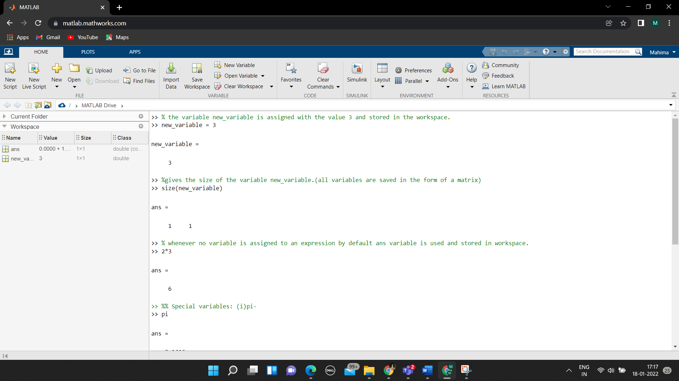

* Special Variables are some inbuilt variables having a predefined value and cannot be used by the user as ordinary variables. Examples are:

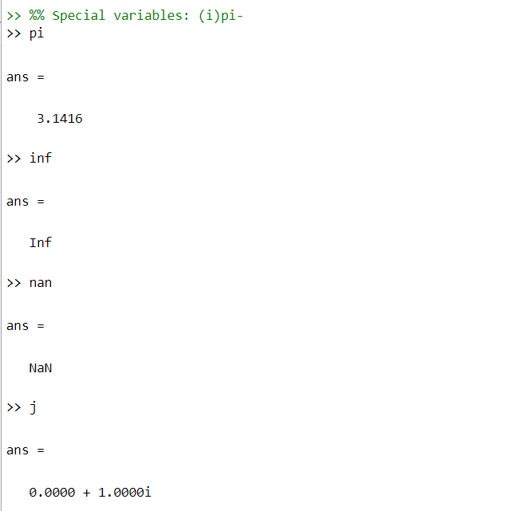

* whos gives all the information about the stored variables.

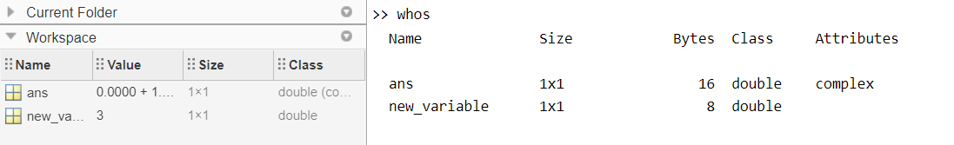

1. VECTORS

* There are 2 types of vectors – Row vector and Column vector. If we put a semicolon at the end of the definition of the vector the ans won’t be printed on screen and would be just stored in the workspace.

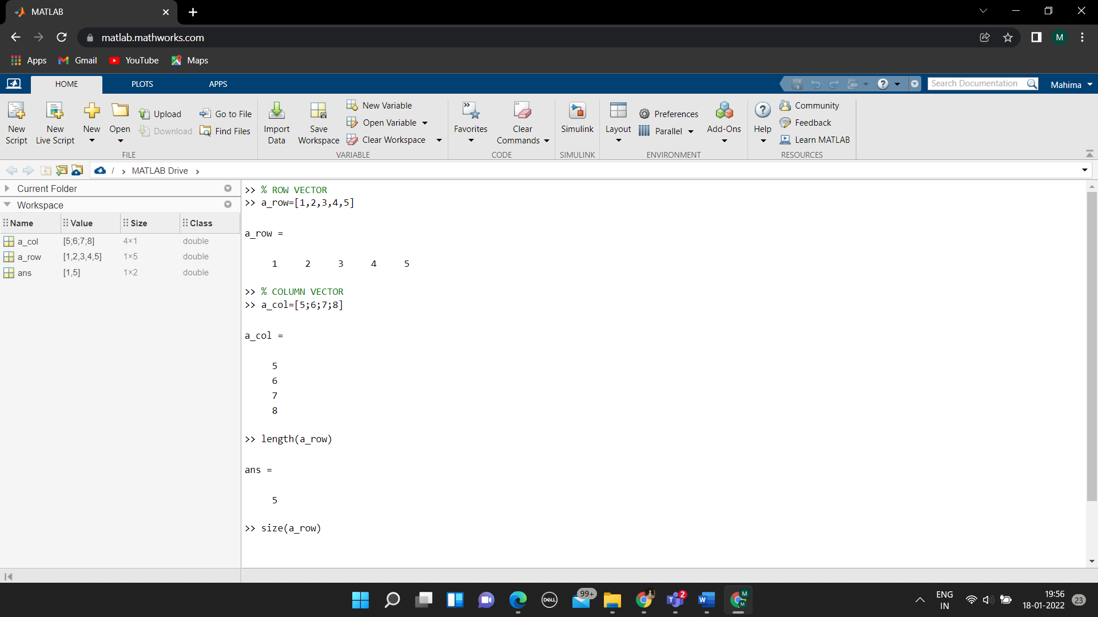

* length gives the length of a vector.
* size gives the size of a vector.
* a_row’ gives the transpose of a vector a_row.

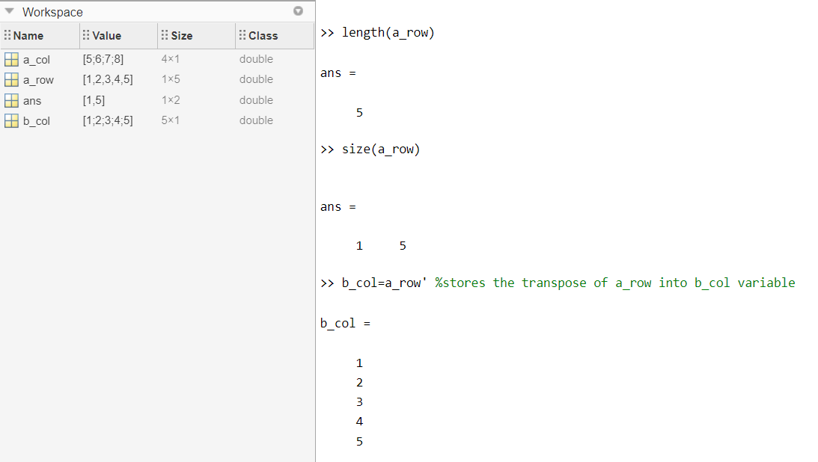

* A particular element of the vector can be accessed using the indexes as shown in the example.
* Indexing starts from 1 (and not 0).
* A new element can be added or the existing elements’ value in a given vector can be overwritten as shown in the examples.
* A particular set of elements of a vector can be obtained.

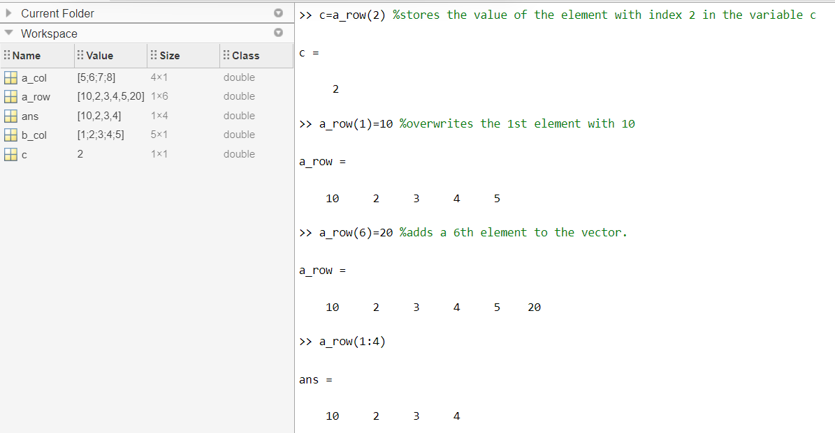

* To assign a set of values to a vector without actually mentioning each value.
* To assign a vector with a series with constant incrementation (ex: odd nos.).
* linspace is used to get required no. of linearly spaced values b/w 2 given nos.

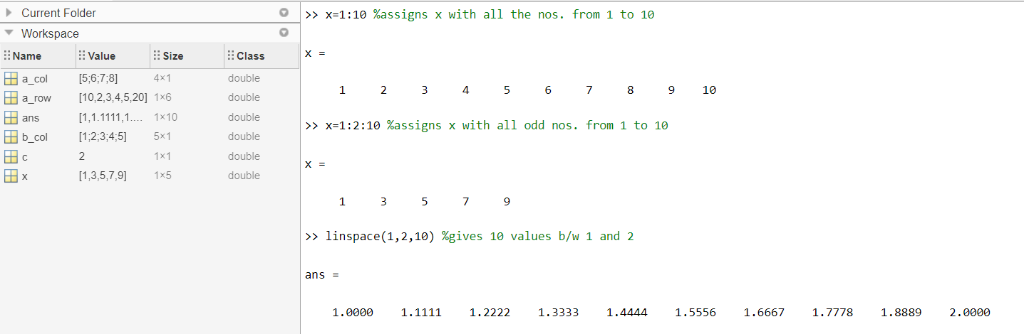

* Dot product of 2 vectors can be either found using the dot function or using the * operator as shown in the example.

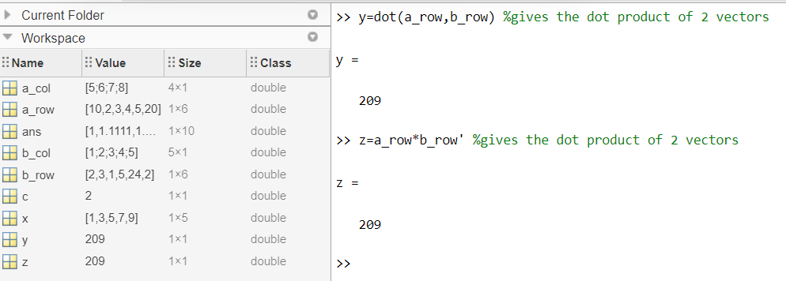

1. MATRIX

* While declaring a matrix the columns are separated using space or comma (,) and the rows are separated using semicolon (;).
* size is used to find the size of the matrix.
* length is used to find the length of the matrix.
* Indexing starts from1 and 0 or -ve nos. are invalid.

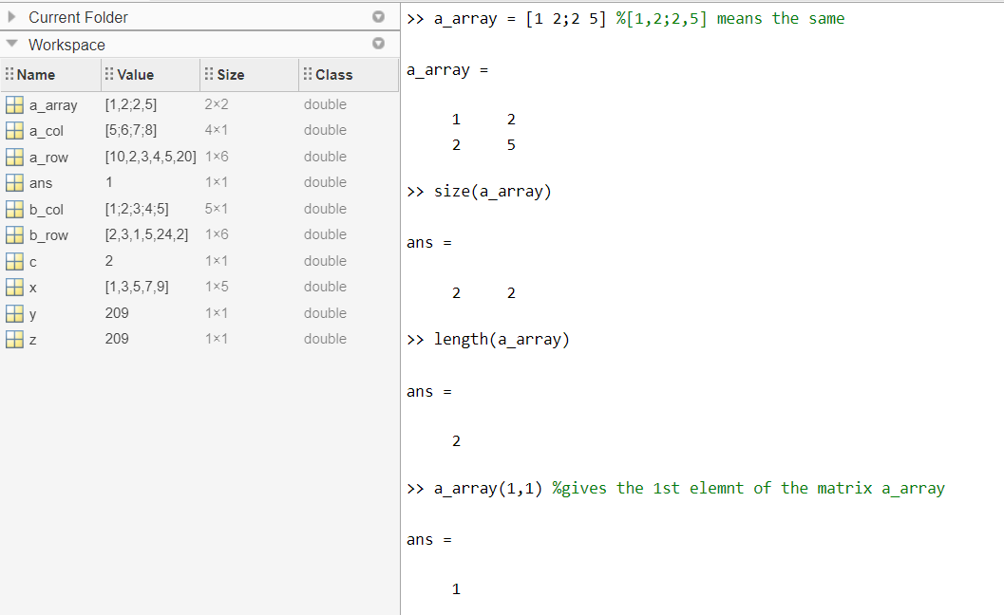

* A constant can be multiplied to all elements of the matrix as shown in the example.
* A particular element of the matrix can be overwritten with a new value using its index as shown in the example.
* We can display the elements of a particular row or column using colon (:) operator and indexing as shown in the example.

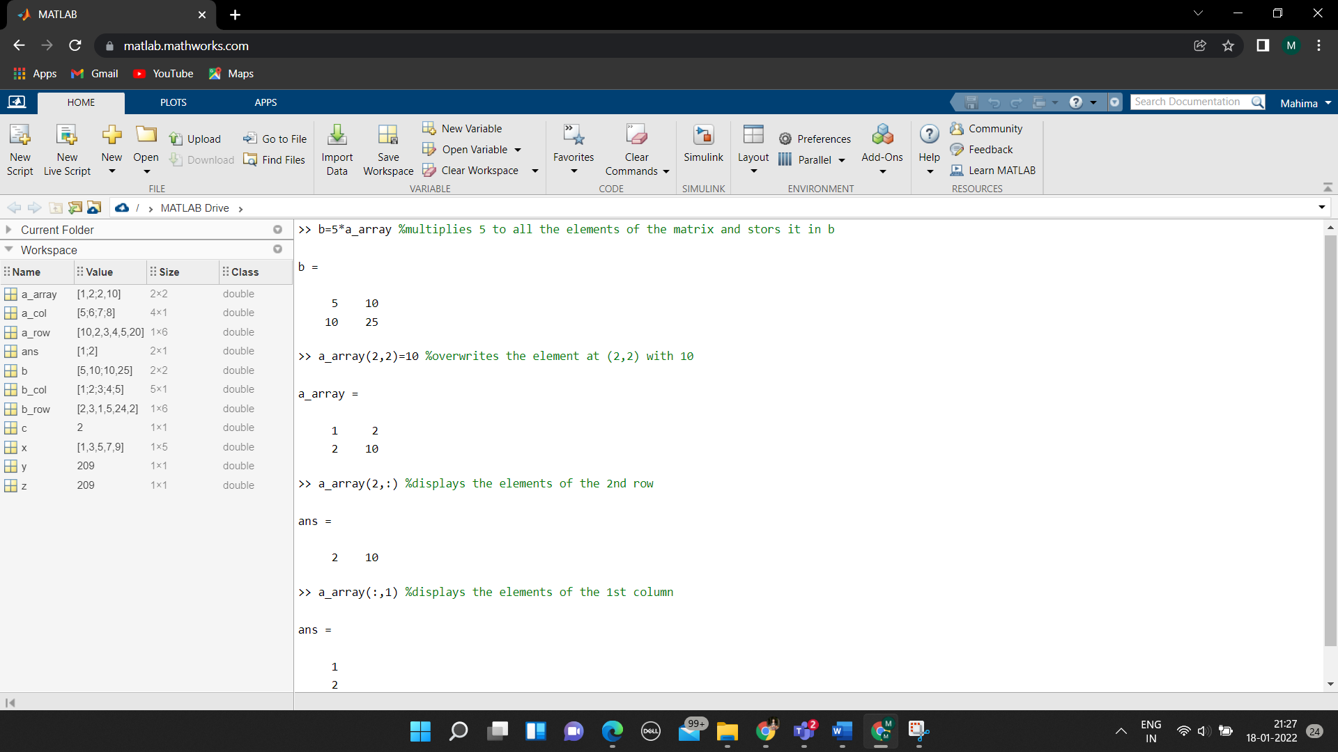

* We can square each element of a matrix using .^2
* We can also multiply the matrix with itself to obtain the whole square of matrix using only ^2.
* sum gives the sum of elements in each column of the matrix.
* diag gives the diagonal elements of the matrix.

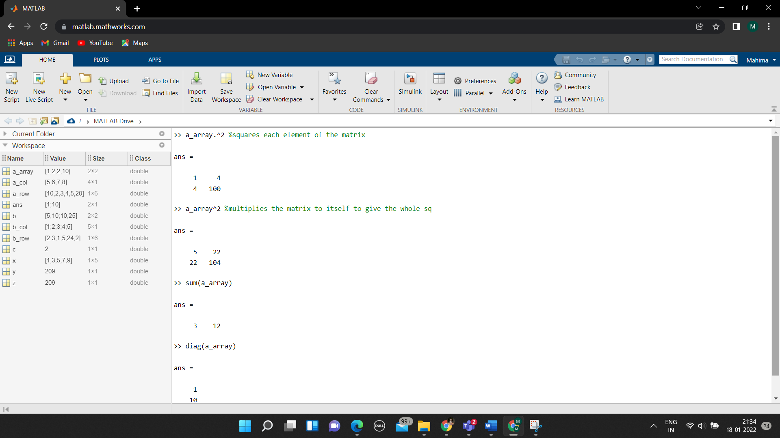

* Special Matrices:

1. ones: gives a matrix of given size with all elements as 1
2. zeroes: gives a matrix of given size with all elements as 0
3. eye: gives a diagonal matrix of given size with the diagonal elements as 1.
4. magic: gives a sq matrix of given value and consists of nos. from 1 to square of the given no.

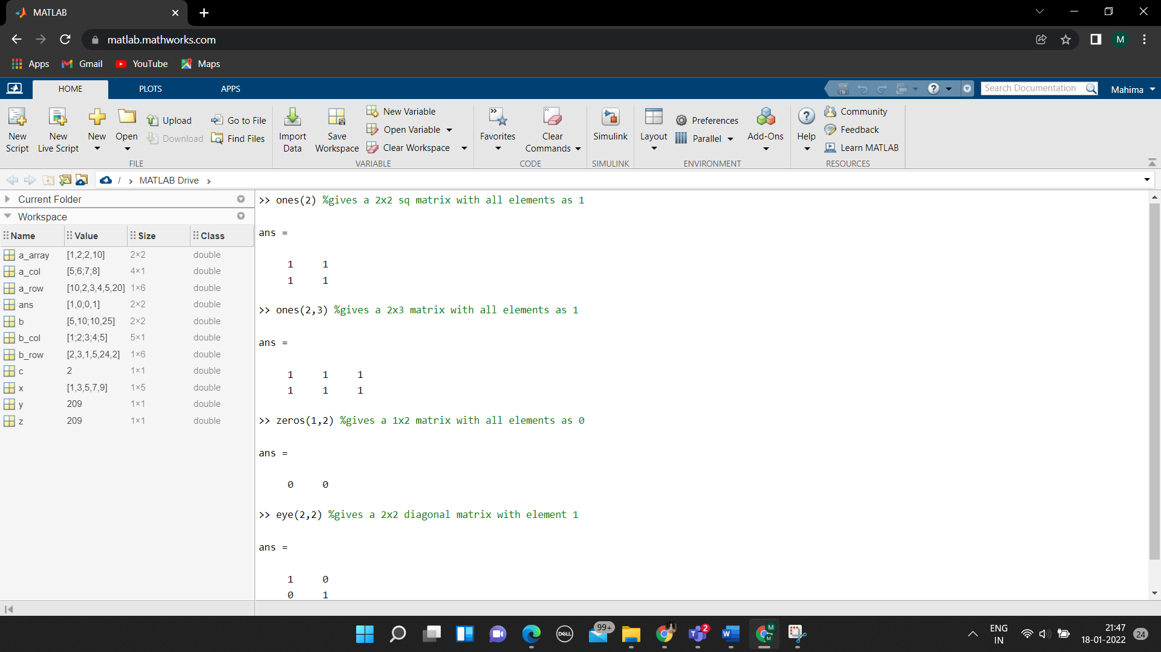

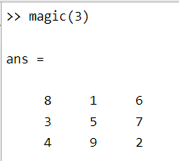

* Inverse of a matrix can be found using inv function.
* Determinant of a matrix can be found using det function.
* When we multiply the determinant of a matrix to the matrix we get a unit diagonal matrix.

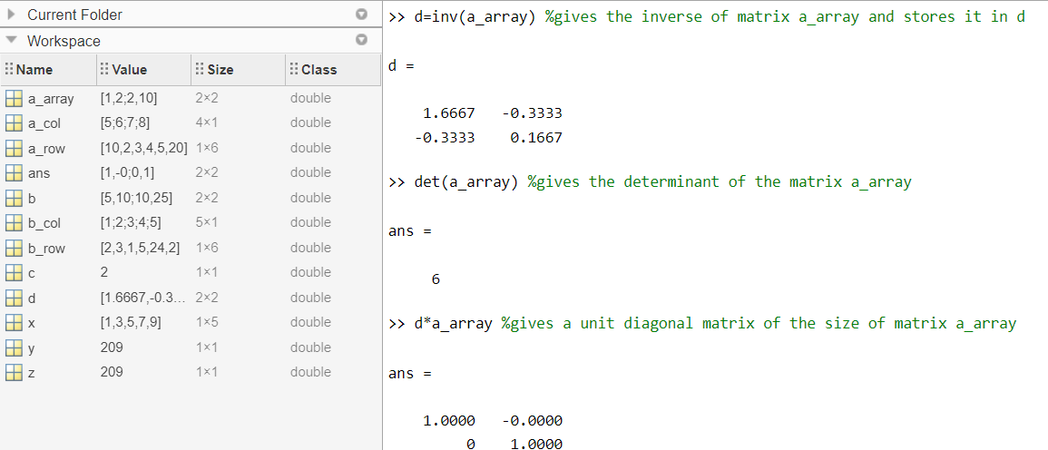

1. EXAMPLE

Given: 5x1+3x2-2x3 = 10

-x1+4x2+2x3 = 5

x1+-2x2-x3 = -2

To find x1, x2, x3.

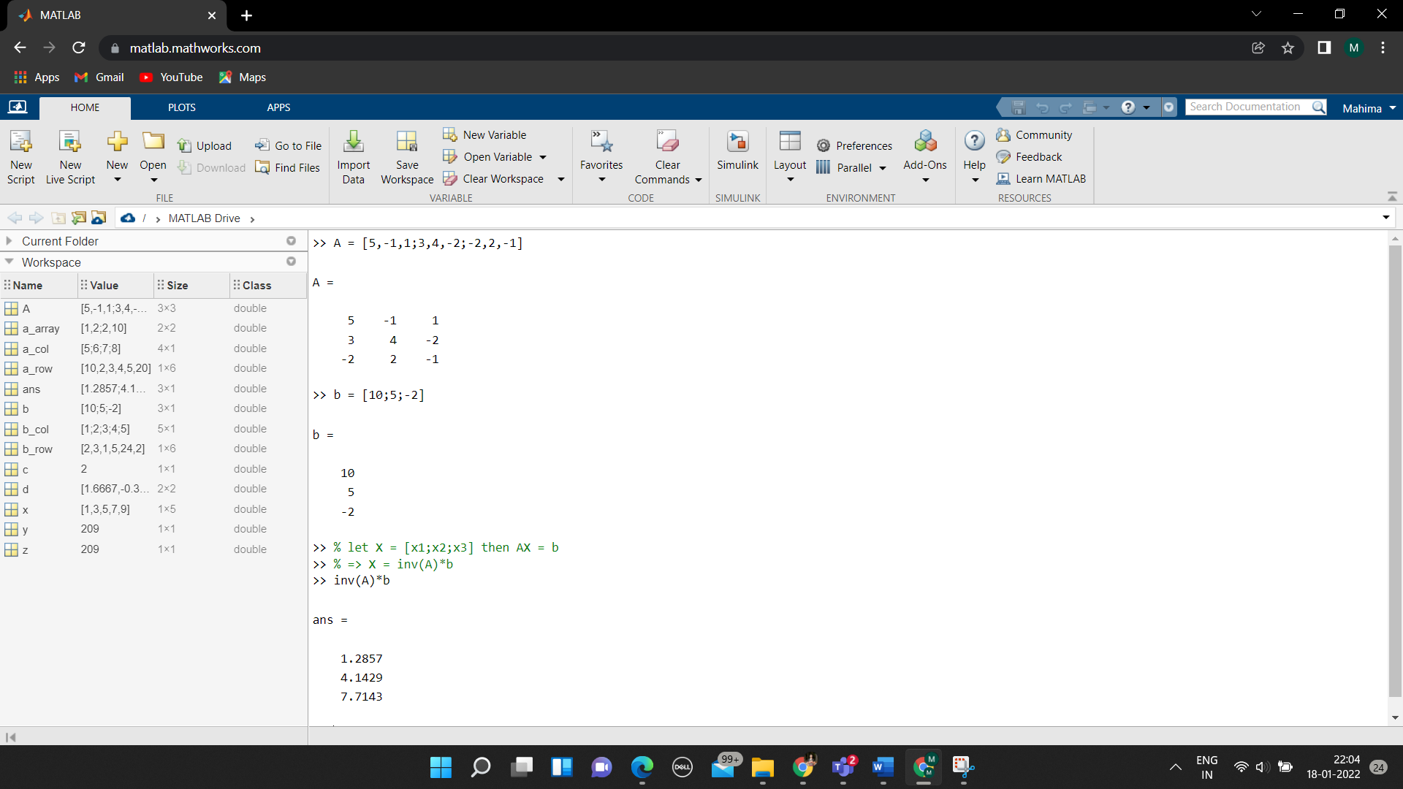

Hence the required values are:

x1 = 1.2857

x2 = 4.1429

x3 = 7.7143

1. Graph Plotting

* To represent a point on graph using a particular symbol can be done using plot function.

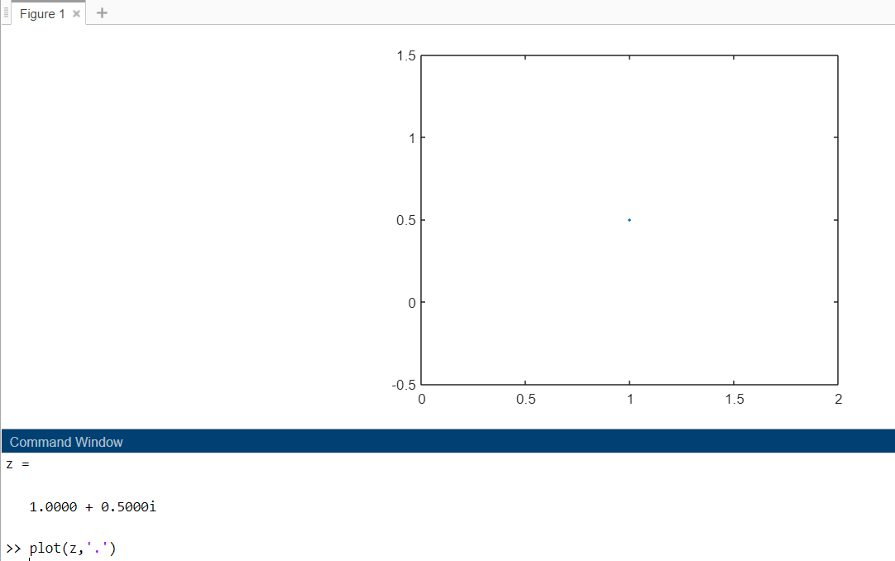

* To plot a sine wave:

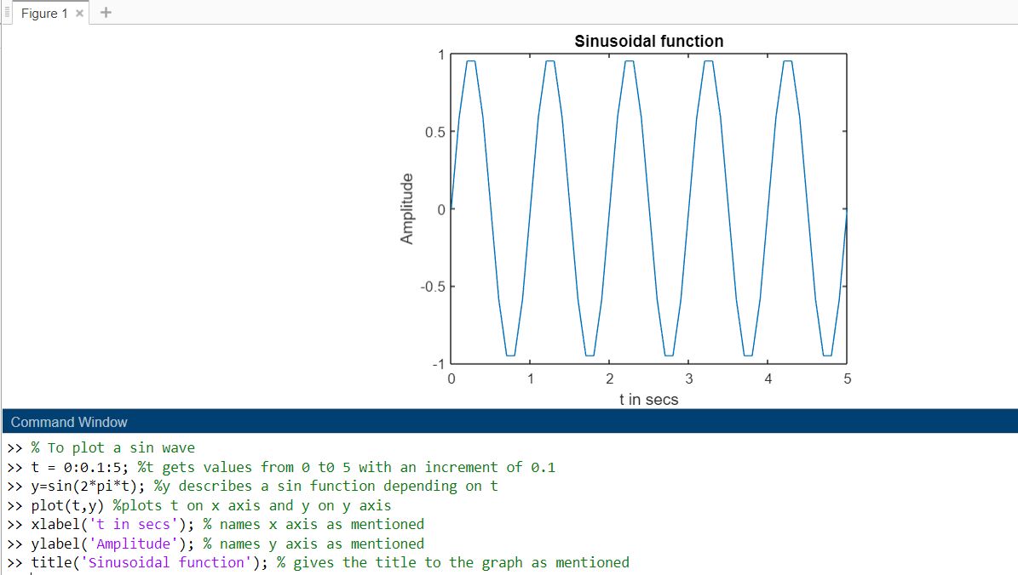

* Plotting more than one graph in the same figure.

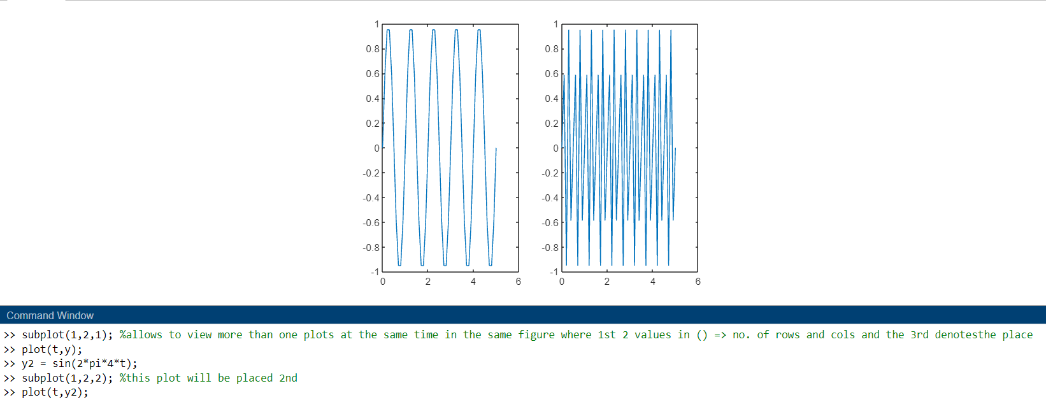

* Plotting 2 waves in the same graph and use of legend.



